**Technical Design Document - ELK**

**Automated ELK Stack Deployment**

The files in this repository were used to configure the network depicted below.

**Network Diagram**

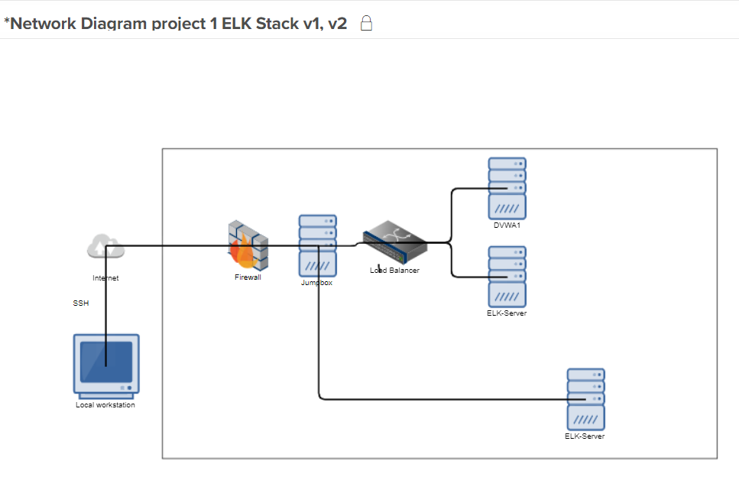

Availability Zone 2

Availability Zone 1

SSH

Security group

| Name | Function | IP Address | Operating System |Public IP

|----------|----------|------------|------------------|

| Jump Box | Gateway | 10.0.0.4 | Linux (ubuntu 18.04) |104.42.52.56

| DVWA1 | Website | 10.0.0.5 | Linux (ubuntu 18.04) |13.64.159.215

| ELK_Server| ELK Server 10.0.0.9 | Linux (ubuntu 18.04) |40.78.98.101

Load balancer ensures that if one server fails the other one takes over and also helps in ensuring that at peak times the load is distributed. New load balancers also provide security function and monitor traffic plus in some cases can provide automated security controls related to unwanted traffic such as brute force.

**Firewall Rules**

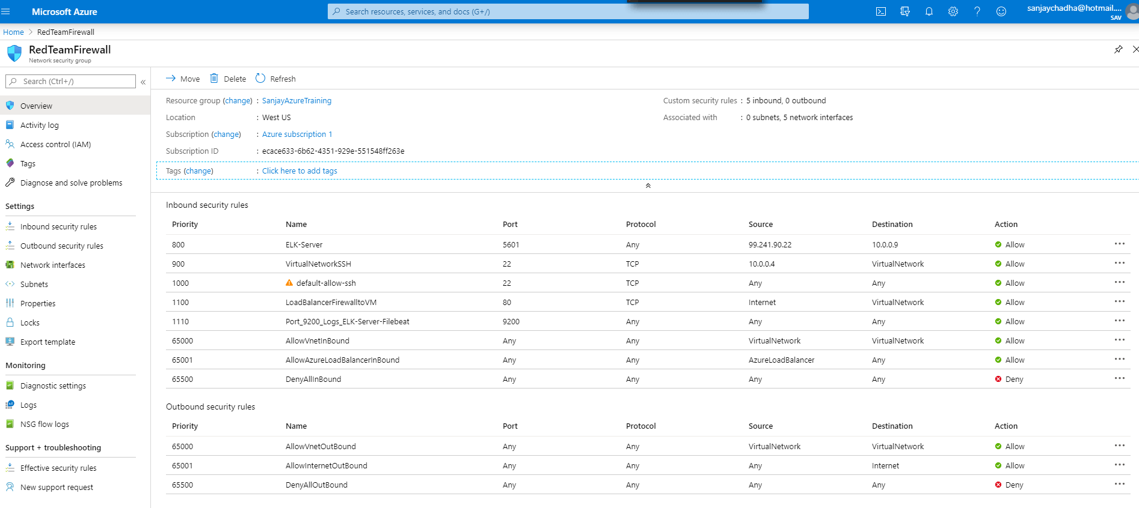

These files have been tested and used to generate a live ELK deployment on Azure. They can be used to either recreate the entire deployment pictured above. Alternatively, select portions of the _____ file may be used to install only certain pieces of it, such as Filebeat.

- TODO: Enter the playbook file.

root@75760fb2e547:/etc/ansible# cat filebeat.yml

---

- name: installing and launching filebeat

hosts: webservers

become: yes

tasks:

- name: download filebeat deb

command: curl -L -O https://artifacts.elastic.co/downloads/beats/filebeat/filebeat-7.4.0-amd64.deb

- name: install filebeat deb

command: dpkg -i filebeat-7.4.0-amd64.deb

- name: drop in filebeat.yml

copy:

src: /etc/ansible/filebeat.config.yml

dest: /etc/filebeat/filebeat.yml

- name: enable and configure system module

command: filebeat modules enable system

- name: setup filebeat

command: filebeat setup

- name: start filebeat service

command: service filebeat start

This document contains the following details:

- Description of the Topology

- Access Policies

- ELK Configuration

- Beats in Use

- Machines Being Monitored

- How to Use the Ansible Build

**Description of the Topology**

The main purpose of this network is to expose a load-balanced and monitored instance of DVWA, the D*mn Vulnerable Web Application.

Load balancing ensures that the application will be highly **available**, in addition to restricting **access** to the network.

- _TODO: What aspect of security do load balancers protect? What is the advantage of a jump box?

Some of the latest load balancer besides routing the traffic to servers based on the utilization, also deflect attacks by shifting traffic.

Advantage of Jumpbox - A jumpbox or jump server can be seen as a system that can divide devices in a separate security zone in a network, for example in the same company a separation of environment can be created between HR, Finance, operations, warehouse etc. A single or multiple jump servers are hardened as per company policy and they can manage and monitor devices in different security zones. Jumpbox can also be used to control access of users between the zones.

Integrating an ELK server allows users to easily monitor the vulnerable VMs for changes to the configuration and system logs.

- _TODO: What does Filebeat watch for?_

Filebeat continuously monitors the log files for specified location(s) and forwards them to Elasticsearch for indexing and monitoring.

- _TODO: What does Metricbeat record?_

Metricbeat collects metrics from the operating system and from the server and forwards them to Elasticsearch for indexing and monitoring.

The configuration details of each machine may be found below.

_Note: Use the [Markdown Table Generator] (http://www.tablesgenerator.com/markdown_tables) to add/remove values from the table_.

| Name | Function | IP Address | Operating System |Public IP

|----------|----------|------------|------------------|

| Jump Box | Gateway | 10.0.0.4 | Linux (ubuntu 18.04) |104.42.52.56

| DVWA1 | Website | 10.0.0.5 | Linux (ubuntu 18.04) |13.64.159.215

| ELK_Server| ELK Server 10.0.0.9 | Linux (ubuntu 18.04) |40.78.98.101

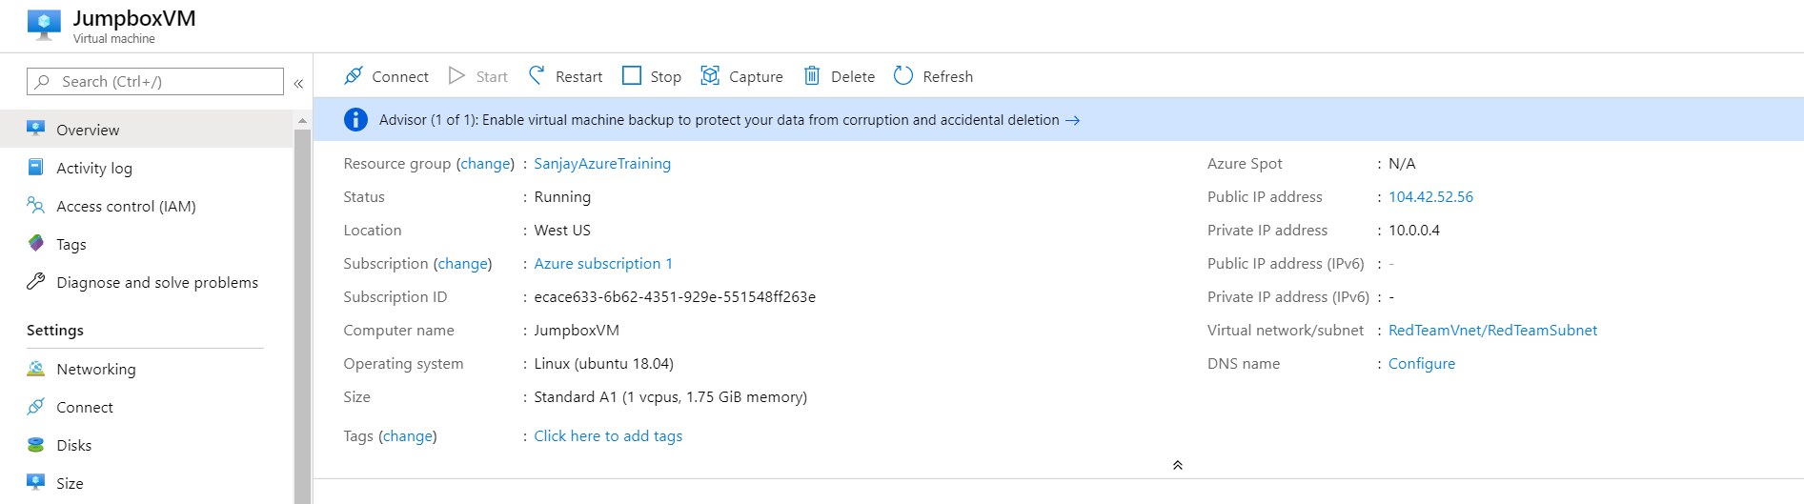

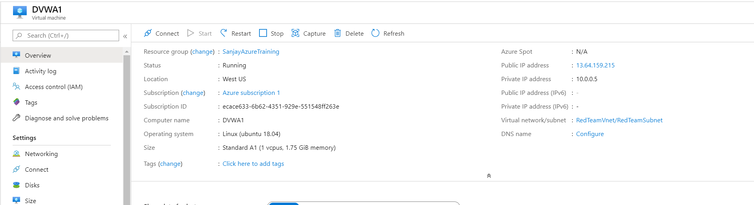

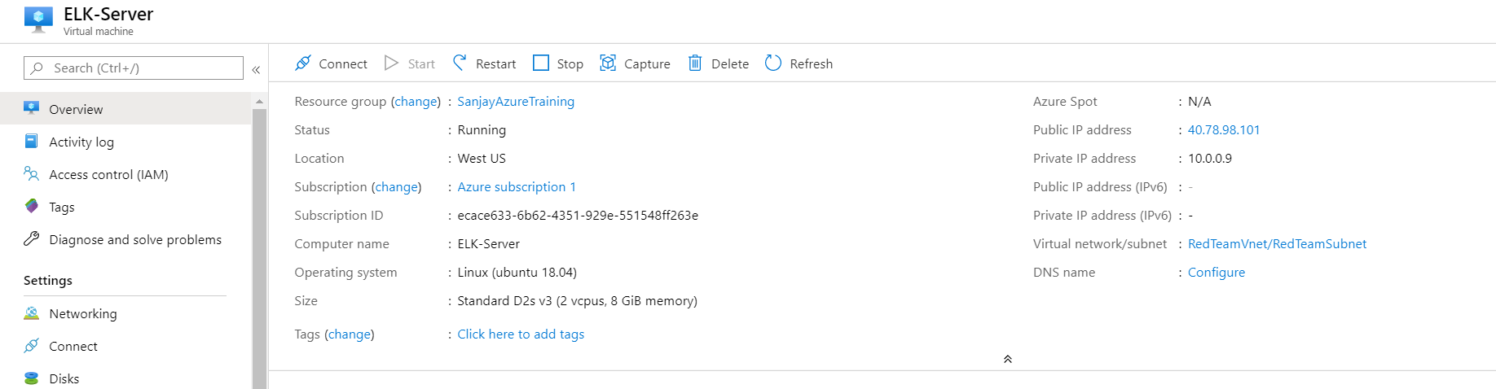

### Access Policies

The machines on the internal network are not exposed to the public Internet.

Only the ELK-Server machine can accept connections from the Internet. Access to this machine is only allowed from the following IP addresses:

- _TODO: Add whitelisted IP addresses 104.42.52.56

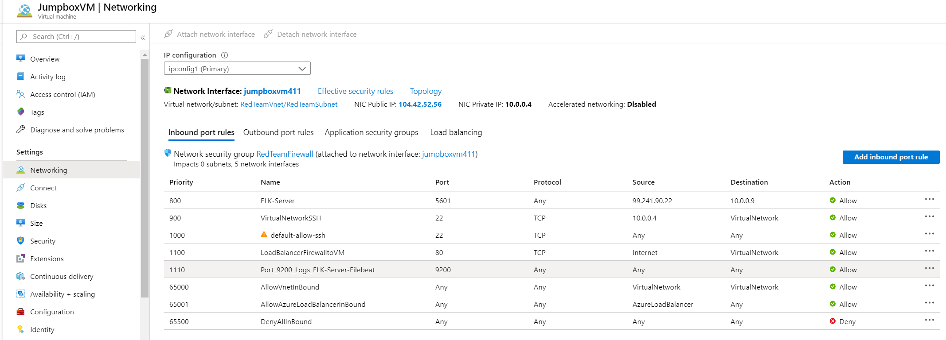

Machines within the network can only be accessed by firewall / Jumpbox.

- _TODO: Which machine did you allow to access your ELK VM? What was its IP address?_

source IP - 40.78.98.101

destination IP – 10.0.0.9

A summary of the access policies in place can be found in the table below.

| Name | Publicly Accessible | Allowed IP Addresses |

|----------|---------------------|----------------------|

| Jump Box | No | 10.0.0.5 10.0.0.9 |

| | | |

| | | |

### Elk Configuration

Ansible was used to automate configuration of the ELK machine. No configuration was performed manually, which is advantageous because...

- _TODO: What is the main advantage of automating configuration with Ansible?_

The yml file can be reused and for multiple machines the same file can execute the common command. Reduces issues and errors.

The playbook implements the following tasks:

- _TODO: In 3-5 bullets, explain the steps of the ELK installation play. E.g., install Docker; download image; etc._

- ...

- ...

The following screenshot displays the result of running `docker ps` after successfully configuring the ELK instance.

![TODO: Update the path with the name of your screenshot of docker ps output](Images/docker_ps_output.png)

**### Target Machines & Beats**

This ELK server is configured to monitor the following machines:

- _TODO: List the IP addresses of the machines you are monitoring_

40.78.98.101

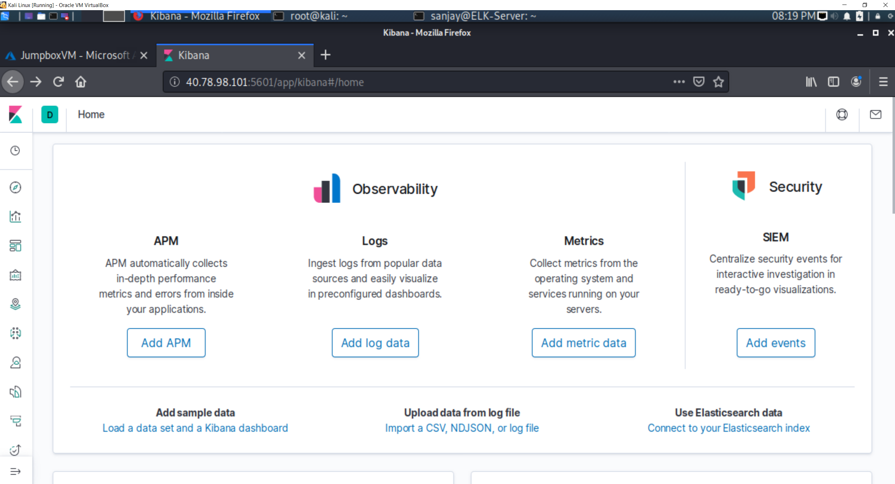

To check logs

Click Logs

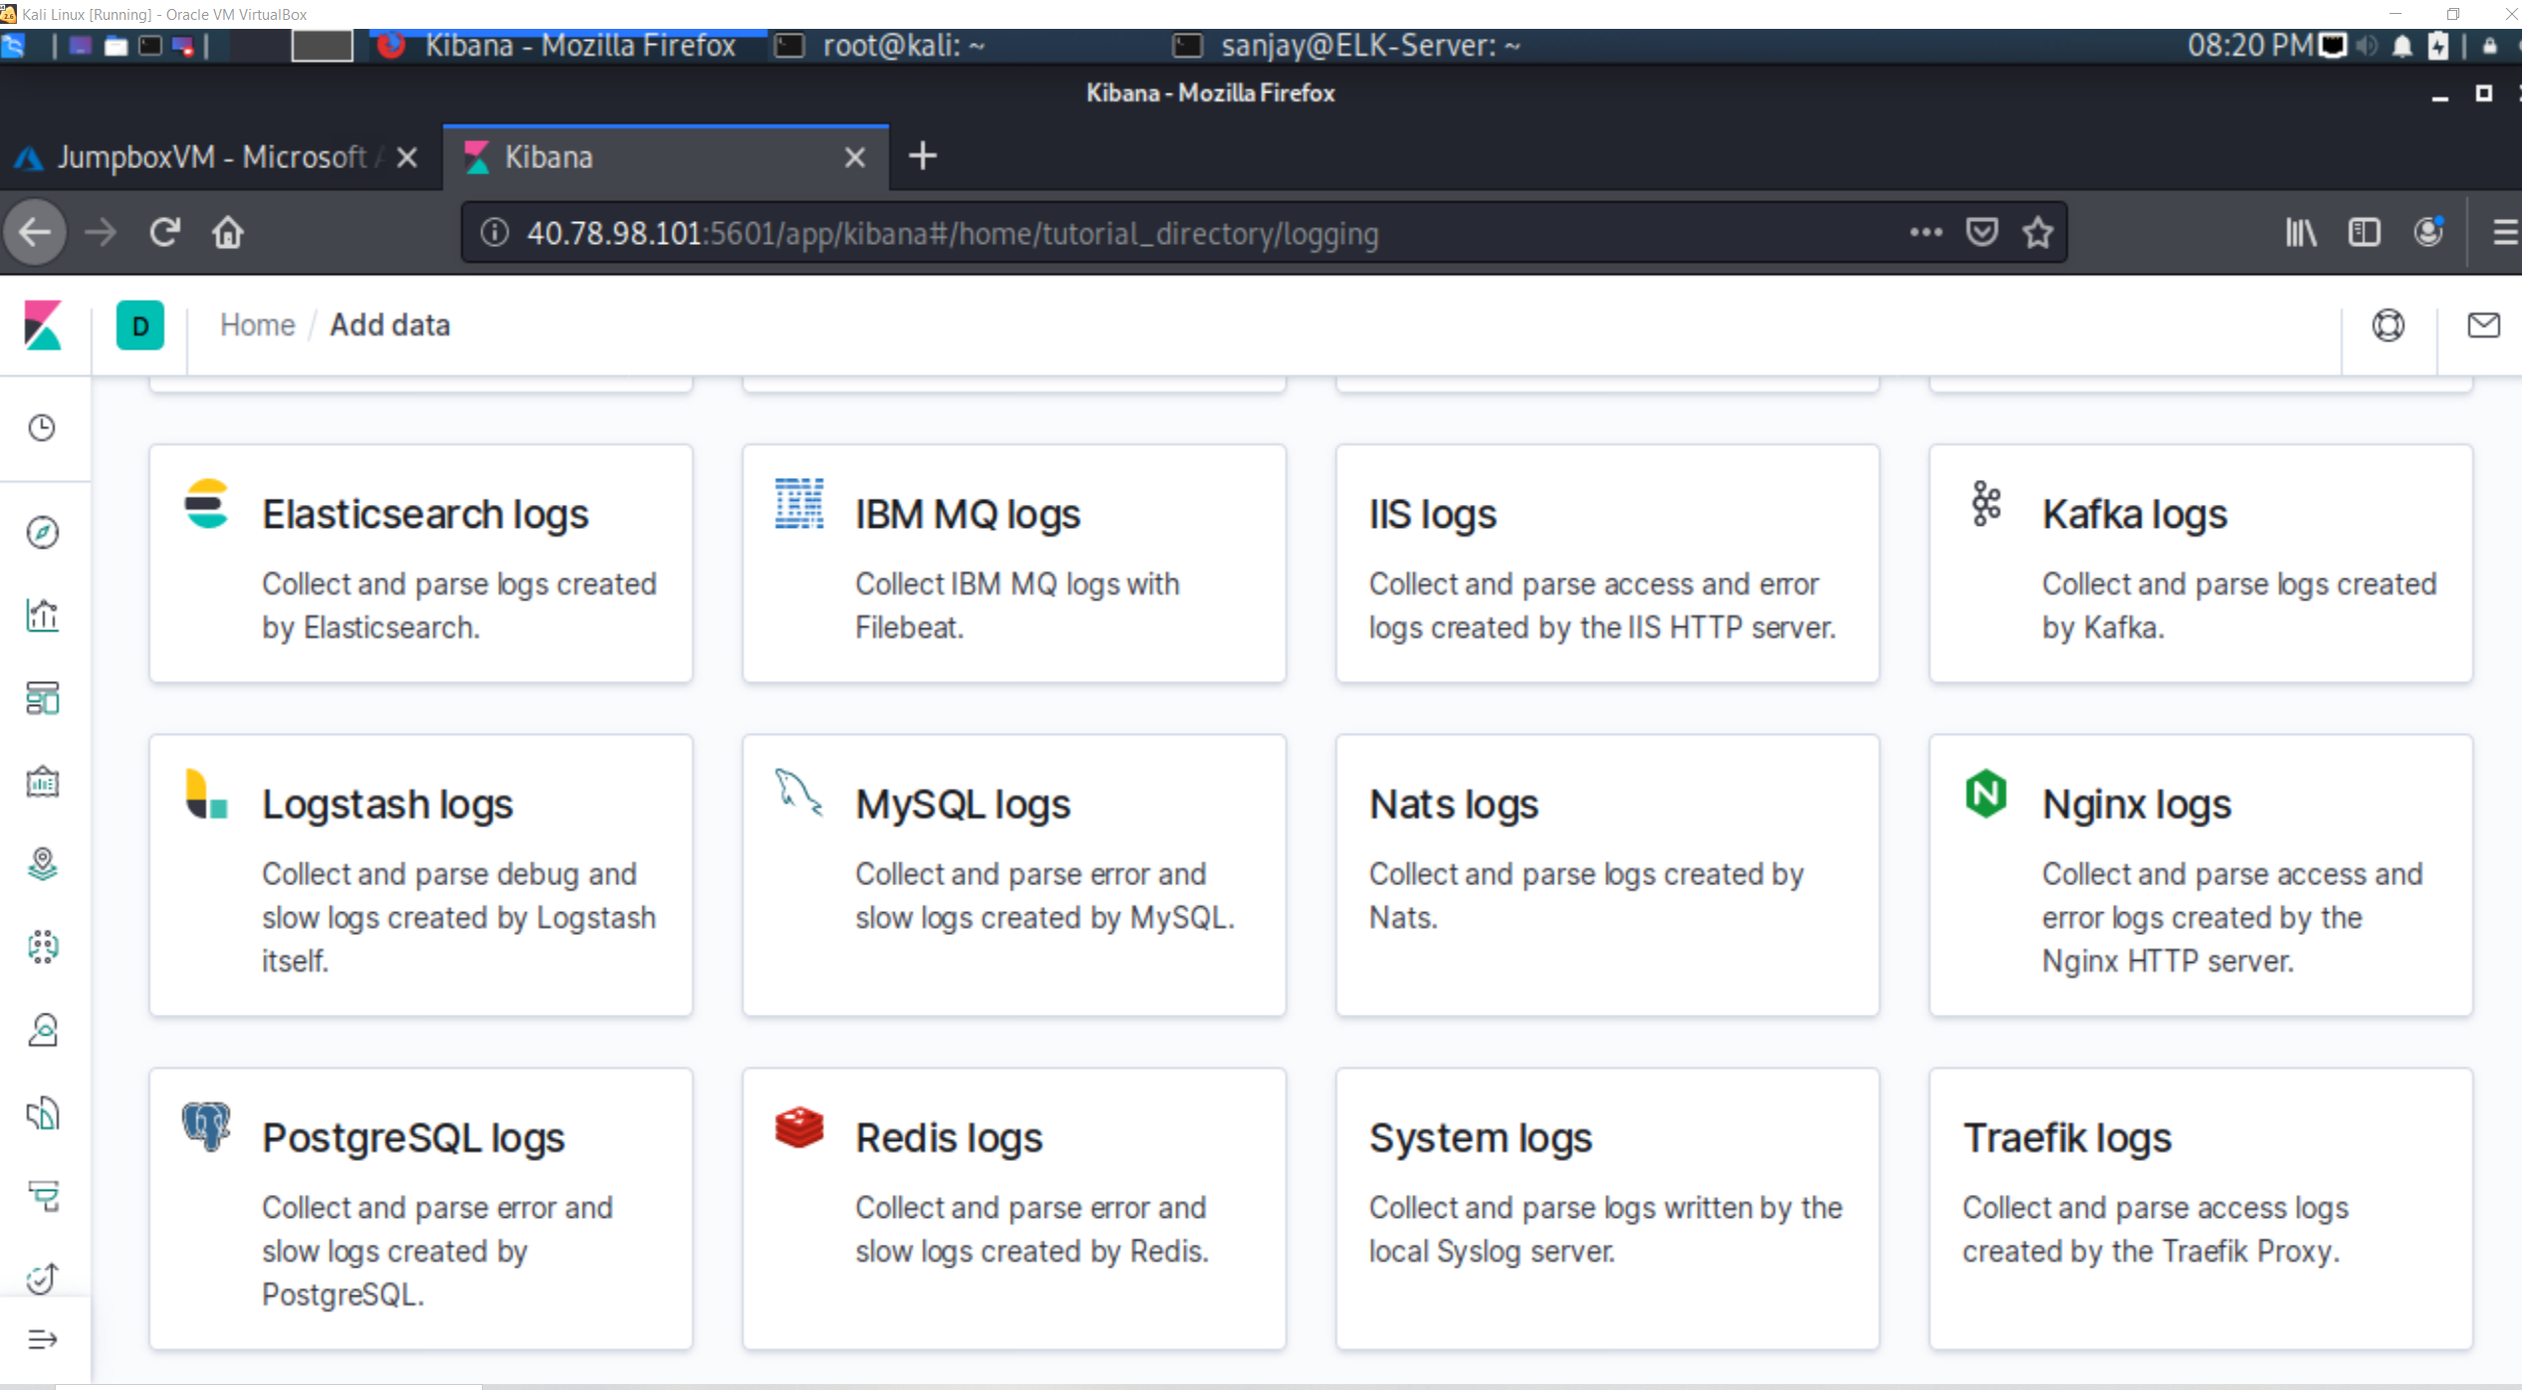

Then system logs

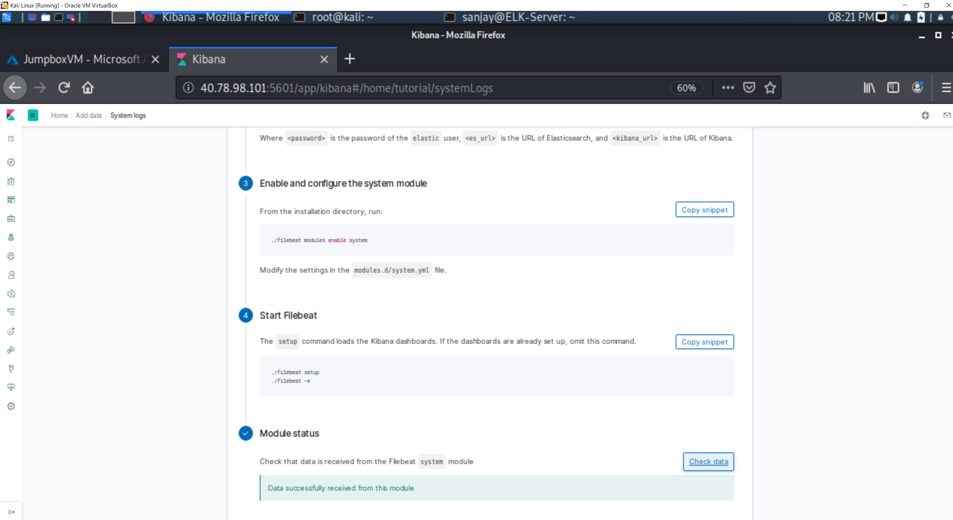

Click Module status and then run “system log dashboard’

We have installed the following Beats on these machines:

- _TODO: Specify which Beats you successfully installed_

**yes**

These Beats allow us to collect the following information from each machine:

- _TODO: In 1-2 sentences, explain what kind of data each beat collects, and provide 1 example of what you expect to see. E.g., `Winlogbeat` collects Windows logs, which we use to track user logon events, etc._



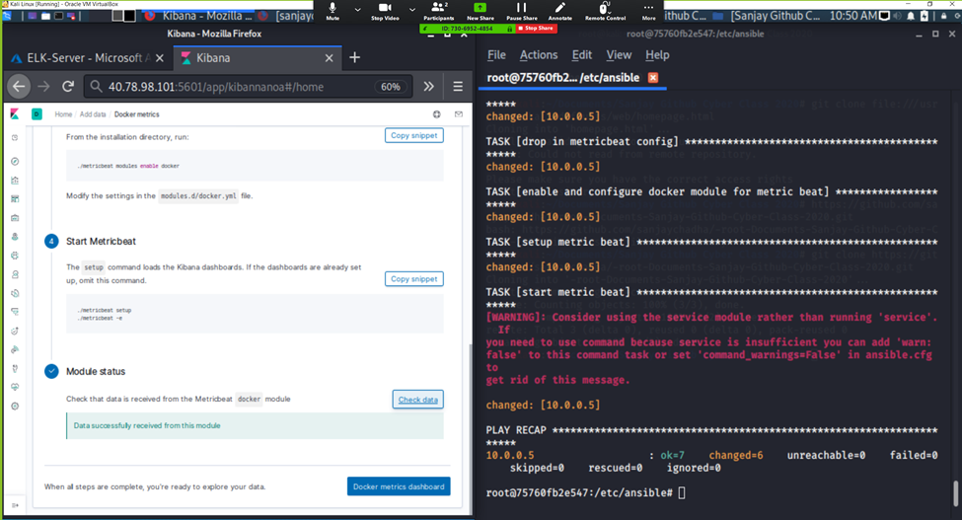

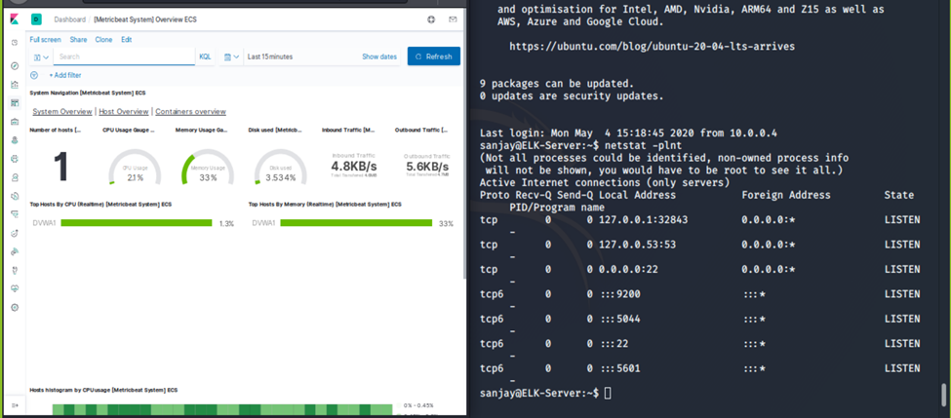

### Using the Playbook

In order to use the playbook, you will need to have an Ansible control node already configured. Assuming you have such a control node provisioned:

SSH into the control node and follow the steps below:

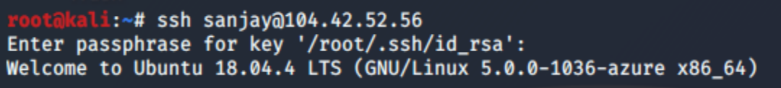

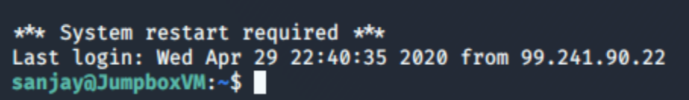

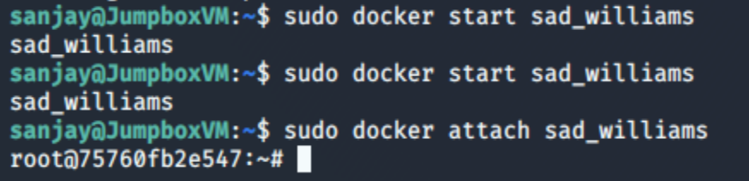

- Copy the configuration file to Folder.

- Update the configuration file to include command

- Run the playbook, and navigate to the Kibana website to check that the installation worked as expected.

_TODO: Answer the following questions to fill in the blanks:_

- _Which file is the playbook? Where do you copy it?_

Elkserver.yml and copy in the ansible server / container

- _Which file do you update to make Ansible run the playbook on a specific machine? How do I specify which machine to install the ELK server on versus which to install Filebeat on?_

Hosts file by specifying webserver and elkserver

- _Which URL do you navigate to in order to check that the ELK server is running?

Public IP address of ELKServer

Or using

Ssh into private IP address and running netstat -plnt command

_As a **Bonus**, provide the specific commands the user will need to run to download the playbook, update the files, etc._

Ansible-playbook elserver.yml